Pressure Solutions

1. Passive
   1. Vent(s)

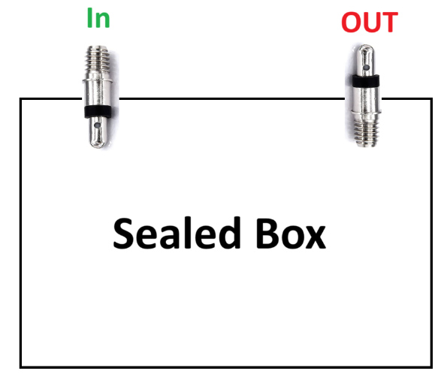

Releasing pressure upon ascent and taking air in trough the descent. Vents block outside air so thermal stability via ascent is possible.

|  |  |
| --- | --- |
| Pro | Contra |
| * Super easy * Cheap * Reliable | * Lets in air on the descent,   cooling difficult (but not impossible if good managed) |

* 1. **Variable Volume Chamber**

Ein Bild, das medizinische Ausrüstung, Spritze, Nadel, Im Haus enthält.
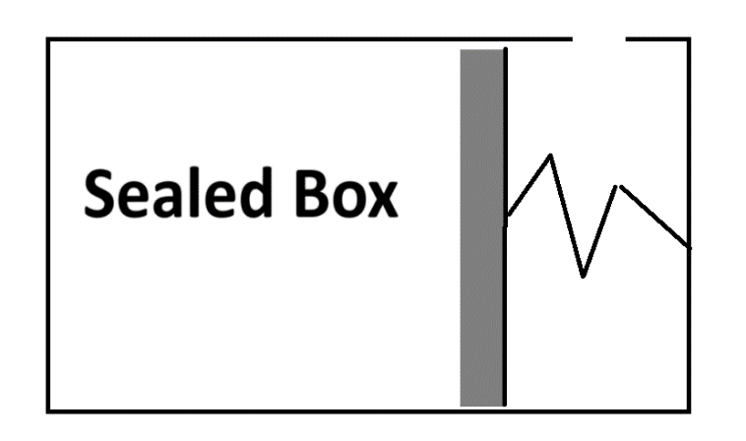A flexible chamber or bag inside the payload can expand or contract with changes in pressure. This helps to minimize pressure differentials and maintain a more constant internal pressure.

|  |  |
| --- | --- |
| Pro | Contra |
| * Constant temperature -> no cooling on the descent | * Complex * Expensive |

Maybe possible with a modified hydraulic car brake system?

* 1. Membrane

A flexible membrane or diaphragm can separate the payload into two sections. As pressure changes, the membrane flexes, helping to equalize pressure differentials.

This Membrane would be one of the walls of the payload.

* Difficult to find a suitable membrane
* Huge Thermal losses
* Hard to engineer to reliability
  1. Vacuum chamber

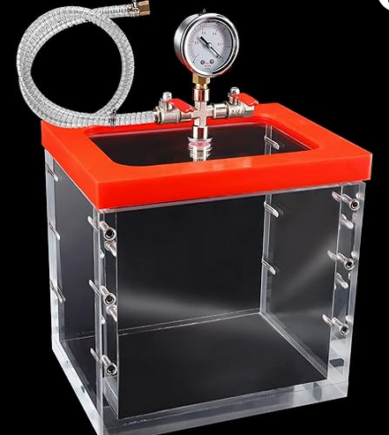

The experiment is contained in a (probably glass) container and pressurized to the pressure between min and max amplitude.

|  |  |
| --- | --- |
| Pro | Contra |
| * Reliable * Giga Chad in terms of heating | * Power/electric contacts very difficult   (wireless transmission?)   * Could heat up too much. (bad) * very expensive |

* 1. Hole

Like vent but worse because of dissipating of heat.

1. **Aktive**
   1. **Pump**

**Bad Idea. We don´t have the power and its complicated.**